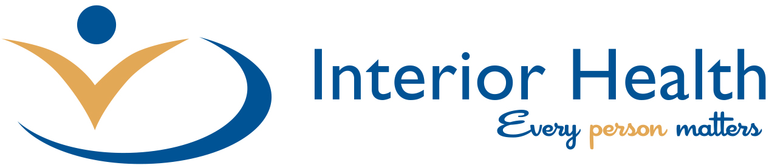

A Designated Agency Framework and Policy is currently under development by Interior Health. The Designated Agency Policy will speak to the different roles and expectations for Interior Health staff.

