REACT Online Edits
MODUALE ONE
Edit 3: http://www.bcreact.ca/dev/wordpress/modules/module-1/react/documenting-an-investigation/#1541808178095-e19d7586-2f59
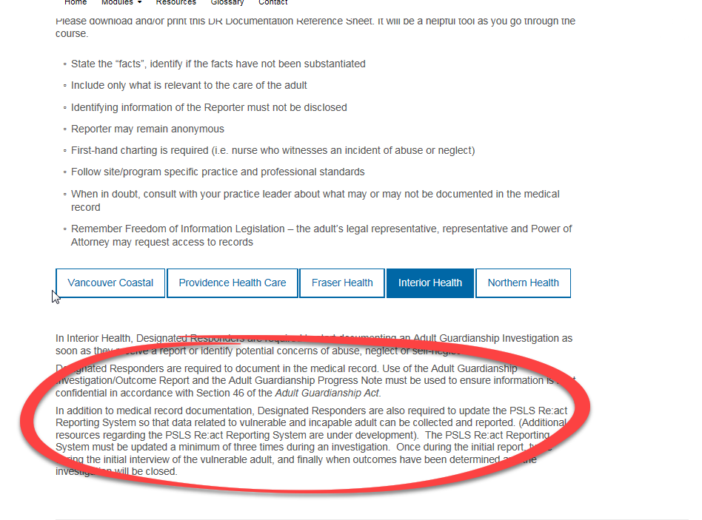
Please add the following PDF’s below this section

Edit 4: http://www.bcreact.ca/dev/wordpress/modules/module-1/respond/two-concepts-to-remember/
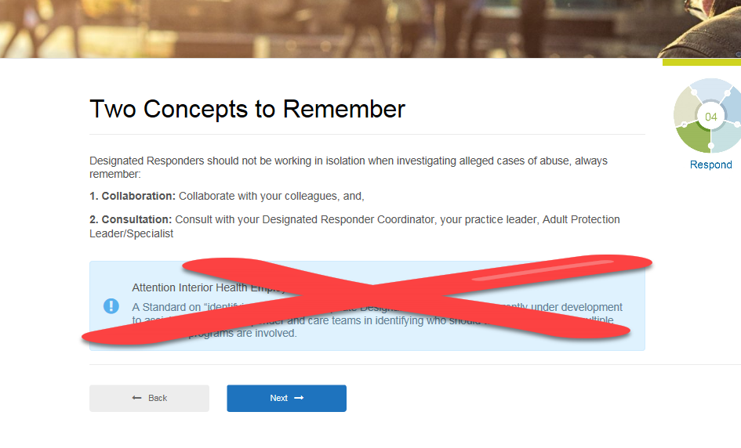
Please Remove this section

MODULE 2
Edit 5: http://www.bcreact.ca/dev/wordpress/modules/module-2/recognize/health-authority-policies/#1543256040669-dd47375a-9a2b
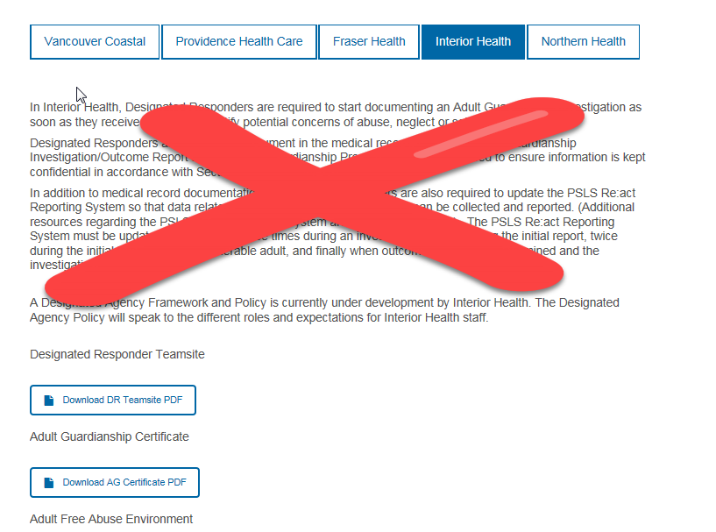
Please change wording to: These are the policies and supporting documents pertaining to Interior Health. For more information please contact Brett Butchart, Knowledge Facilitator for Vulnerable and Incapable Adults brett.butchart@interiorhealth.ca
Please add the following PDF’s to this page as well
UPDATE 2 policies
UPDATE

Edit 7: http://www.bcreact.ca/dev/wordpress/resources/#1543256040669-dd47375a-9a2b0ae4-82e5
Please add the following PDF

